

1. Overview

This proposal outlines the development of a private, real-time dashboard to monitor the health status of machines across Daikibo’s four factories. The solution will provide Daikibo staff with a clear, centralized view of equipment performance, enabling faster response to failures and minimizing production downtime. The dashboard will be accessible exclusively within Daikibo’s intranet and integrated with the company’s existing authentication system to ensure secure access.

2. Scope

The proposed system will include the following key features:

* **Dashboard Overview:** A single-page application showing the current health status of all nine machines in each of the four factories.
* **Collapsible/Expandable Views:** The ability to expand or collapse the factory and device-level panels for easy navigation.
* **Historical Status View:** Access to past status history for each machine, allowing for basic trend analysis and root-cause tracking.
* **Real-Time Updates:** Machine telemetry will be processed and displayed in real time.
* **Authentication:** Integration with Daikibo’s internal authentication server to allow employees to log in using their existing company-wide credentials.
* **Intranet-Only Access:** The dashboard will only be available on Daikibo’s internal network, ensuring both security and performance.

*(Please see included graphics for a schematic representation of the proposed dashboard layout and user interactions.)*

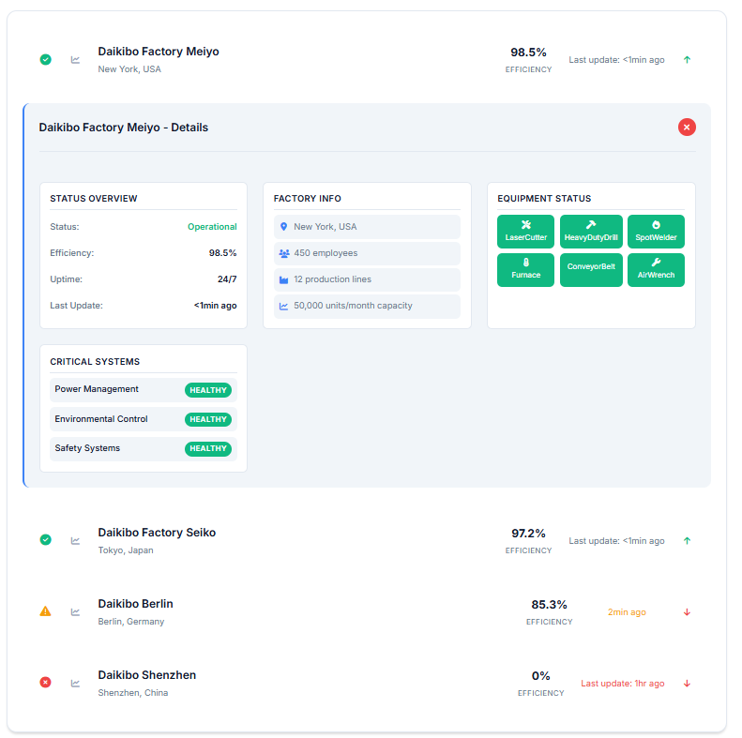

3. Estimate

The estimated total effort for development, testing, and integration is **240 man-hours**, broken down as follows:

* **Development:** 160 hours
  + Backend data processing and API integration: 80 hours
  + Frontend dashboard design and implementation: 80 hours
* **Testing:** 40 hours
  + Unit, integration, and user acceptance testing
* **Integration & Deployment:** 40 hours
  + Authentication integration and intranet deployment

4. Timeline

* [15 September 2024] Design starts
* [22 September 2024] Backend and frontend development begins
* [6 October 2024] Authentication and intranet integration
* [13 October 2024] Internal testing and bug fixing
* [20 October 2024] User acceptance testing with client stakeholders
* [27 October 2024] Final adjustments and production deployment

5. Support

Following delivery, Daikibo can rely on ongoing product support, including:

* **Bug Fixes:** Prompt resolution of technical issues affecting operations.
* **Support Tickets:** A dedicated channel for logging issues and feature requests.
* **New Functionality:** Option to expand the dashboard’s capabilities (e.g., advanced analytics, predictive maintenance) in future development phases.